Reporting Design

Version: 1.2

Overview

Its has been decided by the architecture team that all processing related to reporting is to occur on a separate reporting server. There are several requirements relating to the creation of requests on the Reporting Server:

- All projects will share a common instance of the reporting server.
- Invocations on the reporting server need to be asynchronous.
- Invocations may be of the following types:
  - Oracle Report
  - Printing
  - Send via FTP
  - XSL-FO Render
  - XSLT Render (Word Processing)
  - FXSL Render (“flexible” XSLT)
  - FXSL-FO Render (“flexible” XSL-FO)
- There is a requirement for use cases that combine these actions e.g. Create Oracle Report then Print.
- Solution must support Load Balancing and Fail Over.

Reporting Framework

In order to support a common application instance for all projects, it is necessary to split out the server-side framework code into separate Reporting Framework project. This will hold all code that will be deployed within the reporting application server. Its is critical all projects be set up to use that same version of the Reporting Framework. In addition there is some code that must be shared between the Server Framework and Reporting Framework. This code will be placed in a third project called Common Framework.

Invoking the Report Server

The invocation request from the application server is handled using a standard pipeline component. Invocations to the Report Server may contain a set of requests that should be executing synchronous and in the order specified. E.g.

<InvokeReport project=”caseman” xpath=”/params/param[@name=’ReportRequest’]”>
<ReportStore id=”java:SupsDS”/>
<Destination>ReportsHigh</Destination>
</InvokeReport>

To invoke a report the input must be an XML input to the task must conform the report request XSD schema (see Appendix – 1).

The InvokeReport pipeline component will be responsible taking the incoming XML and constructing the persistent report instances. The InvokeReport object will then construct a report reference XML structure which is sent to the reporting server via a JMS queue. The report reference will be also returned to the user as the output of the InvokeReport component.

The InvokeReport will reuse the destination code from the Async processing module. Destinations will be configured in the project_config.xml for each project. There will be two queues, one high priority and one low priority. High priority is used for tasks that require a near real-time response. This would include transformations for word processing. The low priority queue should be used for everything else including Oracle reports. The destinations are configured as follows:

<item id="ReportsHigh" class="uk.gov.dca.db.impl.AQConfigurationItem">
<factory>java:comp/resource/reportingAQ/QueueConnectionFactories/myQCF</factory>
<jndi-name>java:comp/resource/reportingAQ/Queues/q1_report_high</jndi-name>
</item>

<item id="ReportsLow" class="uk.gov.dca.db.impl.AQConfigurationItem">
<factory>java:comp/resource/reportingAQ/QueueConnectionFactories/myQCF</factory>
<jndi-name>java:comp/resource/reportingAQ/Queues/q1_report_low</jndi-name>
</item>

Note that a new configuration class ‘AQConfigurationItem’ is supplied. This is to separate the definition of AQ queues for reporting from those used internally for the Async processing module.

The InvokeReport pipeline component is also able to handle resubmission. The user can pass the report request reference back to the InvokeReport pipeline component. The pipeline component will resend the report request to the reporting server via the JMS queue.

The project name specified is the name of the project that is calling the Report Server. This is used by the Report Server to write the results of reporting process to the REPORT_QUEUE table within the projects schema. Valid values for this attribute currently include:

- caseman
- ediary
- familyman
- crest

More will projects will be added as required, this actual value supplied will not be checked within the pipeline component only that the value exists. However an invalid value will result in the submitted report failing. Case is also important.

There are two additional report pipeline components available to users for the management of reports. These are:

<GetReport xpath=”/params/param[@name=’ReportReference’]”>
<ReportStore id=”java:SupsDS”/>
<Destination>ReportsHigh</Destination>
</GetReport>

Given a report reference it will return a response XML structure of the Report in it’s current state from the database.

<CancelReport xpath=”/params/param[@name=’ReportReference’]”>
<ReportStore id=”java:SupsDS”/>
<Destination>ReportsHigh</Destination>
</CancelReport>

Given a report reference it will set the status of the report to cancelled in the database.

Automatic and delay printing are also supported. Automatic print will occur when the user specifies the print details in the report request. If the print details are omitted the report will be generated by not printed. The user can resubmit the report reference in a new request with the print details attached and the report will be resubmitted to the report server. The report will not be regenerated (if it completed successfully the first time) and will then be forwarded on for printing. See Appendix 2 for these 2 use cases.

Components
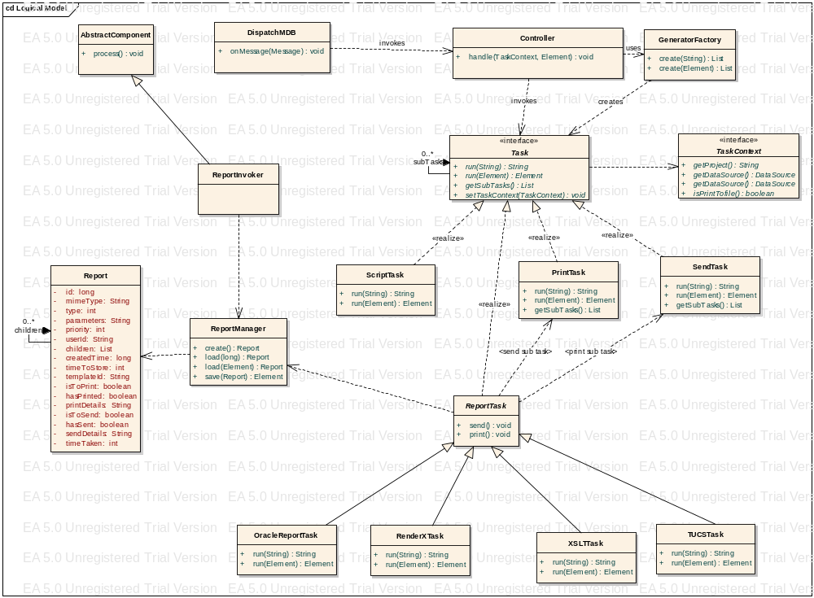
Figure 1 - Class Diagram

There are several key components within the system that handle the processing of the request.

Dispatch MDB
Is responsible for forwarding requests onto the Controller.

Controller
The controller is uses the Generator factory to build of list of generators from the configuration specified within the InvokeReportServer pipeline component. The controller will iterate through list of Generators executing each one in turn. The output of each generator will stored in the response as well as being passed onto the next generator in the list.

Task/Task Factory
The Generator Factory creates Generator instances based on the input from the InvokeReportServer request. Each Generator implements a common interface an will have a concrete definition based upon the type of action to execute. A task may contain sub-tasks, which are dependent actions that may be carried out by that task.

ReportTask
Will serve as a abstract base class for all of the different types of reports. The report task contains 2 sub-tasks, Send and Print. These tasks will be executed if the report has been completed and flags to print and/or send have been set. After printing or sending the appropriate flag in the report will be set. The report will contain the majority of the implementation logic for the handling of reports.

Report/Report Manager
This is a Java representation of the report stored in the database. It will also be used to handle cancellation of the report requests.

Project Identification

As all projects will be sharing a common reporting server instance it will be necessary for a request to identify which project the request is coming from. This information will be used to map into a static per-project map of information. The information contained for each project will be:

- The datasource for the Content Store and Report Queue table.
- Database user id for Oracle Reports.
- Flag to indicate if all reports should be printed to a file.

Physical Model

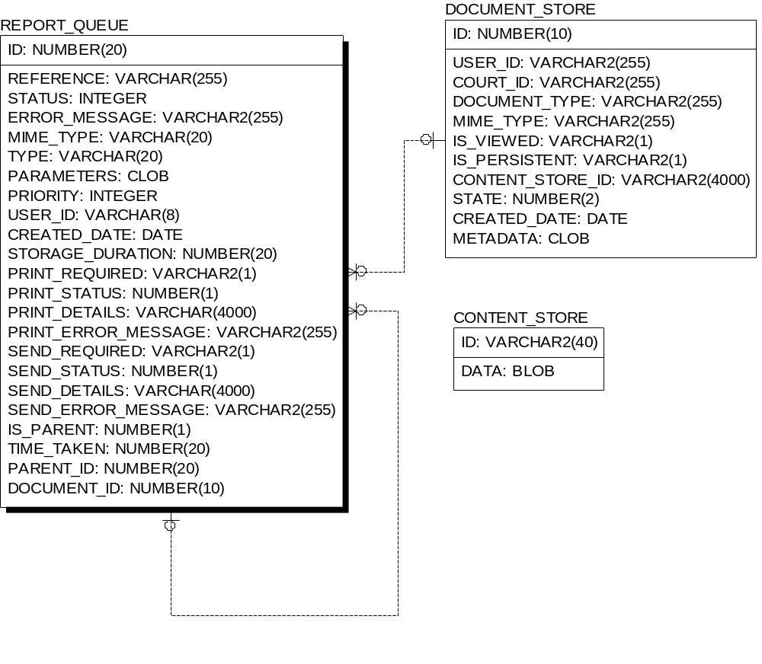
Figure 2 - Physical Model

Processing Reports
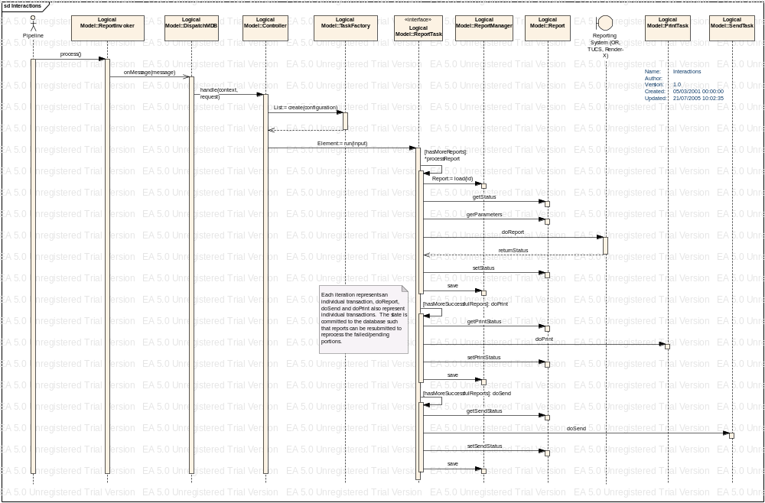
Figure 3 - Report Processing Iteration

Submission/Resubmission
In the instance of creating a new report the user will submit an XML structure conforming to the XSD specified below. In the case of the new report the ‘Id’ value of the report request should be empty and left to the framework the assign the identifier. If the report is submitted with the ‘Id’ value set. The report information will be updated in the database and the report will be resubmitted. If the user simply wish to resubmit the report, rather than specify the entire report a report reference may be used to rerun the unprocessed/in error portions of the report request (this may included printing and sending).

Reprinting Previously Printed Reports
A special report type “ListReport” is provided to support this functionality. A list of references to previously created and/or printed reports is provided as input. See the XSD for details.
Never provide an ‘Id’ for a list report because each request always creates a new report. Also, a list report is a type of batched report and therefore reports included in the list that were originally part of a batch request are reparented to the new list report. This means that if the original batch were resubmitted then it would no longer include the child report reparented to the list report.
Any mixture of report types may be included in the list but they must all have the same print type (i.e. “pdf2ps” or “ps”).

Transaction Management
Each step in the reporting process will handled in its own transaction. Allowing each report to fail independent of any others in the group. If a report fails processing then it will not be printed or sent. There is a caveat here however, as the reporting system, printing system and ftp mechanisms are not transaction it introduces a critical section into the code. If one of actions completes, but for some reason it is not possible to update the database, it will not be possible to rollback the action. In case of resubmission it is possible (however rare) that the action could be carried out twice.

Appendix – 1: Report Request XSD

See “Request.xsd” in common_framework.

Appendix 2 – Oracle Use Cases

Automatic Print:
Client: (Invoke Report).
<?xml version="1.0" encoding="UTF-8"?>
<OracleReportRequest>
<Print>
<PrintDetails>
<Type>String</Type>
<Destination>
<Server>ukprint01</Server>
<Printer>Xerox01</Printer>
</Destination>
<Options>
<Tray>1</Tray>
<NumCopies>2</NumCopies>
<Duplex>false</Duplex>
</Options>
</PrintDetails>
</Print>
<Send>
<Destination>ftp://ftp.host1.gov.dca.gov.uk/reports</Destination>
</Send>
<Reference>12345</Reference>
<OracleReport>
<MimeType>application/pdf</MimeType>
<StorageDuration>1234</StorageDuration>
<Reference>12345</Reference>
<PrintOptions>
<Tray>1</Tray>
<NumCopies>2</NumCopies>
<Duplex>false</Duplex>
</PrintOptions>
<OracleParameters>
<server>String</server>
<report>String</report>
<desformat>String</desformat>
<mode>bitmap</mode>
<destype>String</destype>
<desname>String</desname>
<print_job>String</print_job>
<database>String</database>
<Params>
<Param>
<Name>Text</Name>
<Value>Text</Value>
</Param>
</Params>
</OracleParameters>
</OracleReport>
</OracleReportRequest>

Server:
<?xml version="1.0" encoding="UTF-8"?>
<ReportReference type=”OracleReport”>
<Id>234</Id>
<Reference>12345</Reference>
</ReportReference>

Delayed Printing
Client: (Invoke Report)
<?xml version="1.0" encoding="UTF-8"?>
<OracleReportRequest>
<Reference>12345</Reference>
<OracleReport>
<MimeType>application/pdf</MimeType>
<StorageDuration>1234</StorageDuration>
<Reference>12345</Reference>
<OracleParameters>
<server>String</server>
<report>String</report>
<desformat>String</desformat>
<mode>bitmap</mode>
<destype>String</destype>
<desname>String</desname>
<print_job>String</print_job>
<database>String</database>
<Params>
<Param>
<Name>Text</Name>
<Value>Text</Value>
</Param>
</Params>
</OracleParameters>
</OracleReport>
</OracleReportRequest>

Server:
<?xml version="1.0" encoding="UTF-8"?>
<ReportReference type=”OracleReport”>
<Id>234</Id>
<Reference>12345</Reference>
</ReportReference>

Client: (Get Report)
<?xml version="1.0" encoding="UTF-8"?>
<ReportReference>
<Id>234</Id>
</ReportReference>

Server:
<?xml version="1.0" encoding="UTF-8"?>
<ReportResponse>
<Id>234</Id>
<Reference>12345</Reference>
<Status>3</Status>
<PrintStatus>0</PrintStatus>
<SendStatus>0</SendStatus>
</ReportResponse>

Client: (Invoke Report)
<?xml version="1.0" encoding="UTF-8"?>
<OracleReportRequest>
<Print>
<PrintDetails>
<Type>String</Type>
<Destination>
<Server>ukprint01</Server>
<Printer>Xerox01</Printer>
</Destination>
<Options>
<Tray>1</Tray>
<NumCopies>2</NumCopies>
<Duplex>false</Duplex>
</Options>
</PrintDetails>
</Print>
<Reference>12345</Reference>
<ReportReference>
<Id>234</Id>
</ReportReference>
</OracleReportRequest>

Server:
<?xml version="1.0" encoding="UTF-8"?>
<ReportReference type=”OracleReport”>
<Id>234</Id>
<Reference>12345</Reference>
</ReportReference>

Reprinting

Client (InvokeReport):
<?xml version='1.0' encoding='UTF-8'?>
<ListReportRequest>
<Print>
<Type>pdf2ps</Type>
<Destination>
<Server>uktps550</Server>
<Printer>Xerox</Printer>
</Destination>
<Options>
<Tray>2</Tray>
<Duplex>true</Duplex>
<NumCopies>1</NumCopies>
</Options>
</Print>
<Reference>length 1</Reference>
<ReportReference>
<Id>234</Id>
</ReportReference>
</ListReportRequest>

Server:
<?xml version="1.0" encoding="UTF-8"?>
<ReportReference type=”ListReport”>
<Id>777</Id>
<Reference>length 1</Reference>
<ReportReference type=”OracleReport”>
<Id>234</Id>
<Reference>12345</Reference>
</ReportReference>
</ReportReference>

